**Learning Guide------ARRAYS**

**Definition**

* In computer science, an array is a data structure consisting of a collection of elements.

1. **One-dimensional Arrays**
2. **Declaration & Initialization**

int[] a = new int[length];

boolean[] b = new boolean[length];

String[] s = new String[length];

Also as

int a[] = new int[length];

boolean b[] = new boolean[length];

String s[] = new String[length]; ------not suggested

a[i] refers to the ith element in the array a

Initialize constant array by int[] a = {1,2,3,4,5};

Initialize the whole array with the same element by

for (int i = 0; i < a.length; i++)

a[i] = 1;

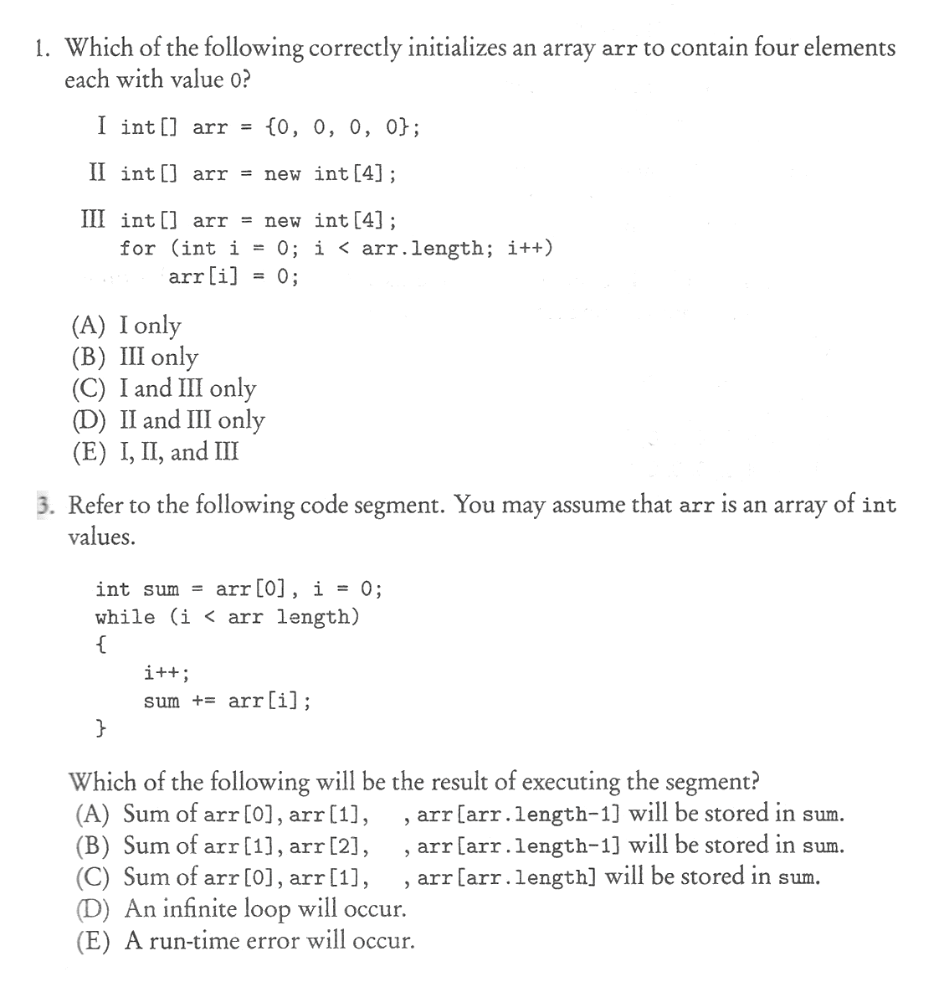

1. **Length of Array**

int length = a.length;

Note

1. To return the length of an array, a.length is correct while a.length() is incorrect.
2. Since the array subscripts go from 0 to a.length – 1; therefore, the test on i in the for loop must be strictly less than a.length.

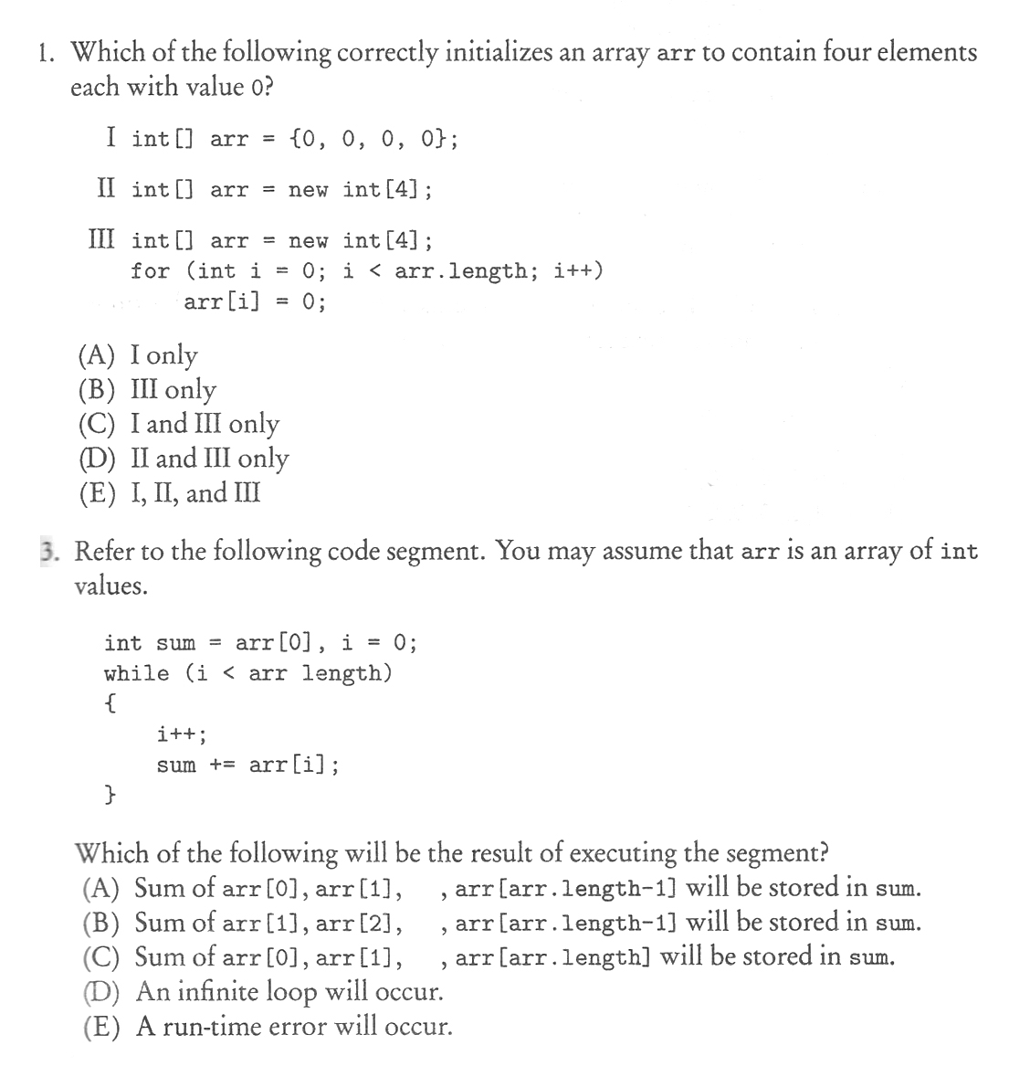

1. **Traversing an Array**

for loop or for-each loop can both be used when traversing an array

for loop is used when and elements.

for-each loop is used when elements.

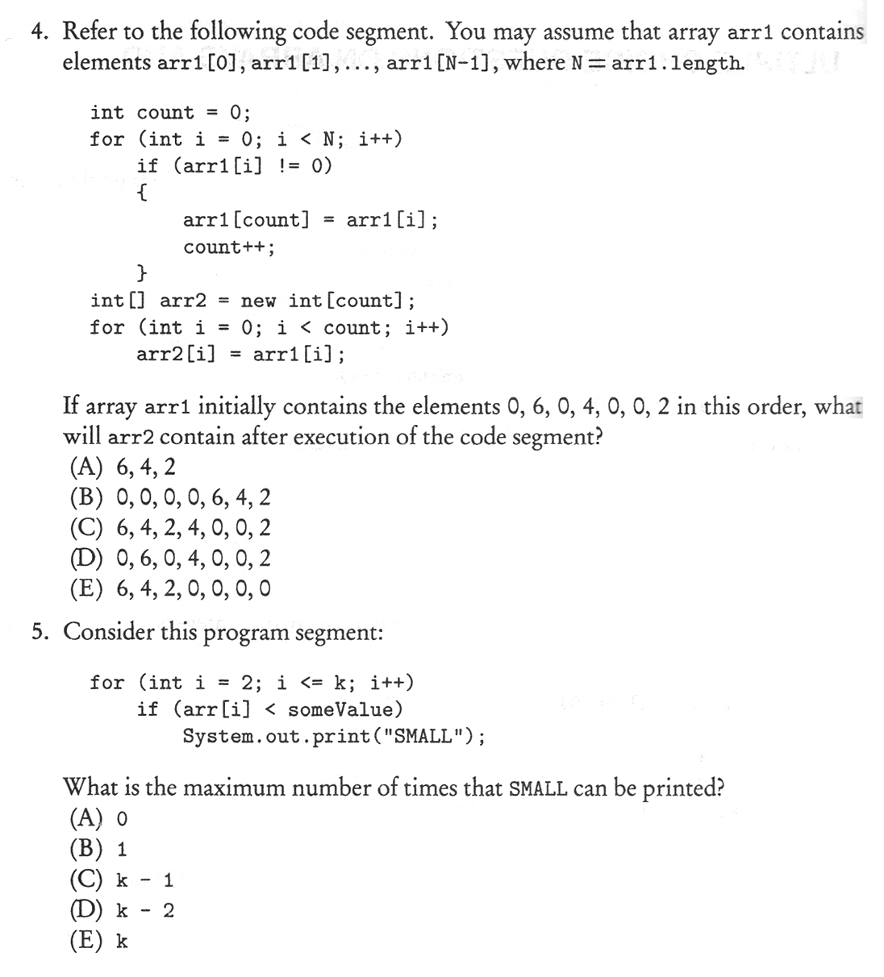



1. **Arrays Package**

import java.util.Arrays;

Arrays.sort(a); //sort the array a in the increasing order

Arrays.toString(a); //return a String that contains all the elements in array a

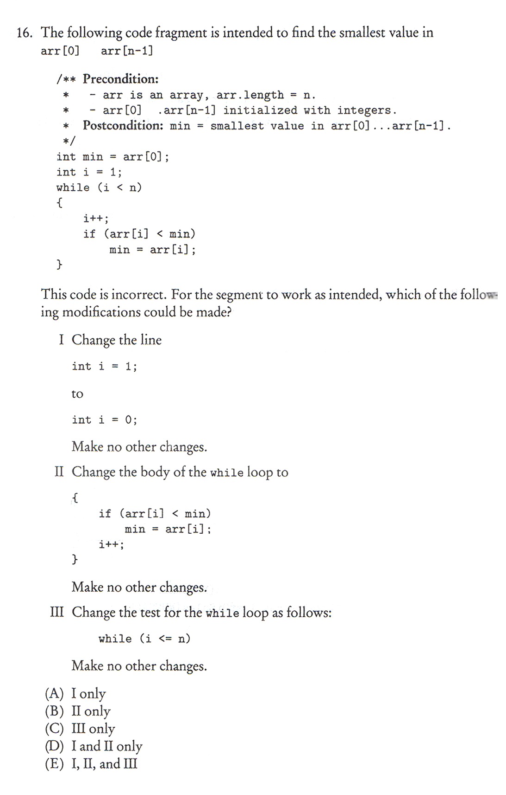**Practice**



1. **Two-dimensional Arrays**
2. **Declaration & Initialization**

int[][] table = new int[3][4];

String[][] s = new String[5][5];

boolean[][] boo = new boolean[7][7];

Specify a two-dimensional array in this way:

int[][] mat = { {3, 4, 5},

{4, 5, 6},

{5, 6, 7},

{6, 7, 8} };

Also as int[][] mat = { {3, 4, 5}, {4, 5, 6}, {5, 6, 7}, {6, 7, 8} };

a[i][j] refers to the element in the row i and column j

1. **Length of Array**

a.length return the length of rows

a[i].length return the length of row i

1. **Traversing an Array**

for loop

for (int i = 0; i < a.length; i++)

for (int j = 0; j < a[i].length; j++)

<process>

for-each loop

for (int[] row : a)

for (int num : row)

<process>

*Think about it!*

How to traversing a two-dimensional array in the following ways:

1. 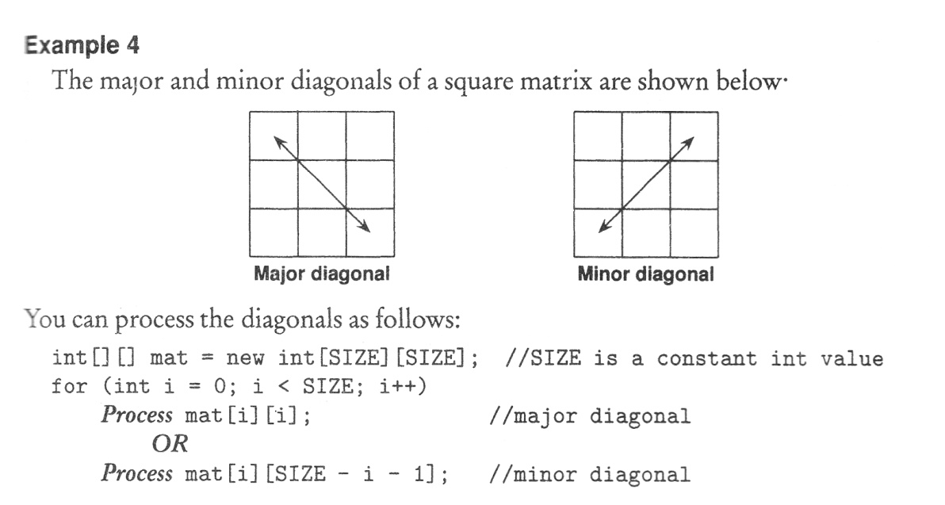major diagonal
2. minor diagonal
3. Back traversal
4. Snake traversal

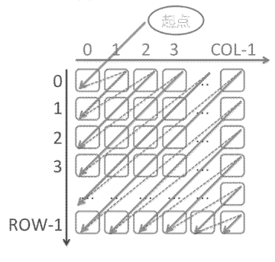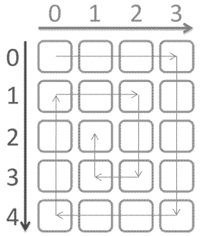

**Practice**

